Mold
Pillar To Post Continuing Education Program



Table of Contents
- Chapter 1: Overview and Objectives

- Chapter 2: What is Mold?

- Chapter 3: Mold Growth

- Chapter 4: Controlling Mold Growth

- Chapter 5: Cleaning Up

- Chapter 6: CEP Quiz

- Chapter 7: Presentation Evaluation

Chapter
1

Chapter 1
Overview and Objectives

Overview and Objectives
Chapter
1
Questions about mold are common in the Real Estate industry. In this workbook we will explore mold as it relates to real estate professionals in their day-to-day dealings with their clients.
This resource will also provide you with more insight into how mold relates to a Realtor’s risk managements and liability concerns
This session is about mold. This course will teach you:

- Some of the characteristics of mold, how it grows and sources.
- How to control mold
- Some methods of cleaning it and remediation
- How to put this into perspective for a client

By the end of this session, the attendee will:

- Have a better understanding of what molds are.
- Be aware of the different categories of mold, toxigenic, allergenic and pathogenic and their effects.
- How molds propagate.
- The common locations of mold in homes.
- How to control mold in basements, laundry areas, bathrooms, kitchens, other living areas.
- Normal cleaning methods for mold.
- Methods of testing for mold.
- Protecting clients’ interests, research at the municipality, mortgage company report requirements, using qualified contractors.

This knowledge will:

- Help you serve your clients better
- Help you answer your clients’ questions
- Show your clients that you are a knowledgeable professional

Chapter 2
Chapter
2
What is Mold?

What is Mold?
Chapter
2
Mold has seen its fair share of publicity in the media over the past years. Most clients will have some awareness of mold and will typically associate mold with the horror stories they have encountered on the daily news. The truth is molds exist everywhere – indoors and outdoors. There are more than 100,000 species of mold. Mold will manifest whenever excessive moisture accumulates in a home or on the building materials within that home. Molds will particularly grow if the moisture problem remains undiscovered or unaddressed.
Mold is often used interchangeably with the word mildew. They are the generic terms that describe a variety of microorganisms, including fungi, algae, rusts, yeasts, and bacteria.
Molds can grow on almost any substance based on moisture and a food source being present. Molds can grow on virtually anything. For example, it can grow on:

- Wood
- Paper
- Carpet
- Foods.

 | There is no practical way to eliminate all molds and mold spores in the indoor environment. So, rather than eliminate mold the key is to control indoor mold growth by controlling moisture

Health Concerns
Minute spores are carried by air, they are deposited everywhere, and everyone breathes them every day. The vast majority are not harmful. Spores and microscopic fragments of mold growth are a natural component of both outdoor and indoor air however, when molds germinate and grow, they can produce large amounts of spores. When allowed to grow, damage to building materials can occur, and when spore concentrations are very high, health can be affected.
Some people react differently than others. Pregnant women, infants, the elderly and those with health problems, such as respiratory disease or a weakened immune system, are more at risk when exposed to mold.
Health experts indicate that, depending on the type of mold present in a home, the amount and degree of exposure, and the health condition of the occupant, the health effects of mold can range from being insignificant to causing allergic reactions and illness. Some molds can have deleterious effects, typically in the form of:
- Toxigenic: means that they can release toxins, strong poisons. (Stachybotrys chartarum, Aspergillus niger, Aspergillus versicolor)
- Allergenic: means that they can cause or aggravate allergies.
- Pathogenic: means that they can cause diseases. (Aspergillus fumigatus from compost – that can be tracked in underfoot, Cryptococcus neoformans from bird droppings and bat dung).
 | Your Client May Ask: Should I be concerned about mold in a home? (This question is generic to all homes – not a home where mold has been identified by the client already)  Your Possible Answer: The truth is molds exist everywhere. There is no practical way to eliminate all molds and mold spores in the indoor environment. What we need to determine in any home is if there are concentrated amounts of mold as this can be the cause of damage to the building as well as health issues.  Ask about the family situation to determine if there are any pregnant women, infants, the elderly and those with health problems. Then, explain why you are asking – Because there can be an increased risk for these groups. You should always ensure that you do not evoke panic and that you utilize a balanced and straightforward approach.

Damage to Materials
Damage to materials ranks as a concern along with health. Materials get stained or discolored, and over time they are ruined by molds. Moldy paper and cardboard disintegrate over time. Fabrics are damaged. Continued mold growth can be indicative of moisture conditions favorable for growth of fungi that cause wood rot and structural damage. This decomposition of organic materials is a vital role that molds play in the natural environment, but works against our desire for a long lasting home!
Insurance companies know from experience that claims can result from mold and set high standards for testing and remediation, even if there isn’t any significant mold present. .

A Word About Grow Operations
The media of late has seized upon the ever increasing number of grow operations emerging across North America. One of the main outcomes of grow operations is serious mold concerns.
 | If you would like to learn more about grow operations and how they impact your dealings with clients, you should contact your local Pillar To Post home inspector who can provide you with an in-depth presentation on this subject along with a corresponding student workbook

 | Check Your Knowledge  Answer the questions below in the spaces provided

- How can mold be eliminated within a home?
____________________________________________________________________________________________________________________________________________________________________________________________________________________________

- How would you respond to a client who asks you about the general consequences of mold in homes?
____________________________________________________________________________________________________________________________________________________________________________________________________________________________
____________________________________________________________________________________________________________________________________________________________________________________________________________________________

- What groups of people are particularly prone to health concerns when it comes to mold?
____________________________________________________________________________________________________________________________________________________________________________________________________________________________

Chapter 3
Chapter
3
Mold Growth

Mold Growth
Chapter
3
Molds produce tiny spores to reproduce and these waft through indoor and outdoor air continually. When mold spores land on a damp spot indoors, they may begin growing and digesting the materials they are in contact with in order to survive. In this sense molds seek nutrients, just as any plant does in order to grow.
Mold spores need a favorable environment to germinate, or become active, grow, and spread. The most important condition mold needs to germinate is moisture. What constitutes a favorable environment is different for each species. After landing on a host material, a spore must obtain sufficient moisture to germinate and find enough food.
Without moisture, mold spores will lie dormant until favorable conditions occur

Where Does Mold Grow?
The simple answer is everywhere but to narrow it down to materials in the home that mold uses as nutrients. These might be:
- Wood products including paneling, subfloors, cabinetry, and structural components)
- Acoustic tile
- Gypsum board (drywall)
- Wallpaper
- Insulation
- Carpets
- Dust - deposited in minute quantities on all surfaces, even those that are inert such as window frames.

How Does Mold Grow?
Mold Propagation (Growth) Requires 4 Elements
- Mold / Fungi Spores
- Nutrients
- Temperature (18 - 24C or 65 – 80F)
- Moisture
  - Bulk Moisture - Leaks and floods
  - RH (Relative Humidity) - The ratio (%) of water in the air to the amount of water that air could hold at the current temperature.
    - Water Vapor – Airborne water introduced into the home via building materials, openings in the building envelope, ventilation systems and humans

Bulk Moisture
The most obvious conditions for the growth of mold is the presence of standing water, leaks, or floods. Bulk moisture can come from infiltration at roofs, windows, foundations, leaks in plumbing systems, leaks around tubs and showers.

RH (Relative Humidity)
As mentioned previously, leaks and floods (bulk moisture) are the most commonly viewed culprits – mold however does not require standing water in order to grow. This is where RH (relative humidity) comes into play.
RH refers to the ability of air to hold water vapor. RH decreases as the air temperature falls and increases as the approaches saturation. When air contains all of the water vapor it can hold, it is at 100 percent RH or greater, and the water vapor condenses, changing from a gas to a liquid (moisture) The temperature at which condensation occurs is the "dew point.".
Most molds will germinate at 65% relative humidity (RH). It is also possible, however, for some molds to grow at a lower RH. These molds are most often found in dry climates.

It is not possible to create an environment free of mold spores. Dormant spores are everywhere, therefore the only dependable way to avoid mold problems is to control the environment so that mold cannot become active. Control of the environment means maintaining moderate temperature and RH (never above 65%)

Factors that Affect the RH in a Home
Everyday Sources: In-house moisture generation (high RH) comes from a variety of common, everyday sources. For example breathing, showering, bathing and mopping the floor.
Water Vapor: This can come from rain soaking into construction materials during construction the house is built with the moisture already it; Condensation inside the house from showering, clothes washing, cooking, breathing, drying clothes. Water vapor also moves into the building through the ventilation system, through openings in the building envelope, or directly through building materials such as paint, plaster, etc.
Water-Rich Materials: All materials contain some water, and for the most part is it bound water. When the amount of water in the air is about 60%, there is usually enough free water to allow for mold growth.

Microclimates
A microclimate is the climate of a small, specific place within the home as contrasted with the climate of the entire area. (i.e. the amount of moisture generated and found within the microclimate differs from the rest of the home.)
A humid bathroom or a damp basement is effectively a microclimate, and it only takes one such room in a home to spread mold spores throughout the entire house. In this sense, microclimates are another key to fungal growth.

Microclimate Examples
Microclimates occur literally everywhere in the home, however the most mold prone are in:
Bathrooms: Moist areas include around tubs and showers at the base. In the grout lines. In cold corners. Inside the walls and floors – shower penetrations, worn toilet seals. Water left on showers and around tubs. Towels drying. Inside cabinets with leaky drains or supply lines.
Closets: Moisture is trapped when wet clothes are stored and the closet door is closed hence there is no air circulation. Closets are also notorious places for home owners to stow any unwanted items to keep them out of sight – these can sometimes be wet boxes, shoes, winter boots, coats or unsightly wet materials of any sort.
Laundry Rooms: Excess moisture from drying clothes in the house on a drying rack or clothesline. Using a dryer with a disconnected duct or a duct not directed outside. Warm room with cold spots around windows and corners.
Bedrooms: Water vapor moves around the house and condensates in bedrooms that are kept cooler. In colder corners. In closets. Behind stored material – mildew blooming. Behind curtains and window blinds. How often do I look behind a blind that is rarely opened and find mold and dirt.
Kitchens: Cooking and washing dishes releases water vapor, gas burning releases water vapor. It can condense in cold corners, on windows, and move to other parts of the house. Leaking drains or supply lines in the cabinet under the sink are notorious for supporting mold growth.

Living Rooms, Dining Rooms, Family Rooms: Living rooms: primarily behind curtains and blinds and sometimes in cold corners
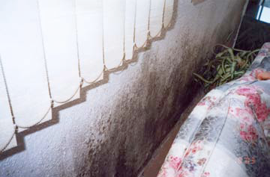
In this image mold is blooming behind stored material and furniture. If we were to look behind the blinds we would expect to find even more mold due to the moisture condensing around the cold window.
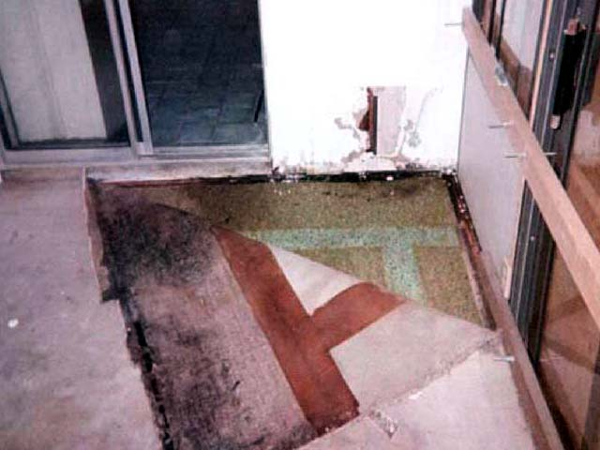
This image shows a living room with a carpet in an area where water has entered near a sliding glass door

Inside walls: Leaks from plumbing lines occur inside walls and ceilings. These have a tendency to propigate the more toxic molds. Water vapor can condense inside the walls and ceilings where it does not evaporate easily, mold can form and has a ready source of nutrients with drywall paper.
A home inspection will not be able to detect mold within walls as the home inspector strictly conducts a visual, non-invasive inspection. This means that a home inspector is obligated by his standards not to destroy property and hence cannot drill into the walls to investigate for mold.
Many home inspectors can however be contracted to perform mold sampling as an additional service to their core home inspection. Mold sampling will typically take the form of swab(s) and/or cutting out a piece and/ or taking air samples.
Attics: Leaks from seepage through old roof coverings, or small holes in the roof coverings, or poorly maintained flashings, or small gaps not easily seen; as well as poor ventilation in the attics and crawlspaces or exhaust ducts terminating inside the attic.
Crawlspaces and Basements: Don’t forget about leaks in foundations in crawlspaces or through the skim coats.
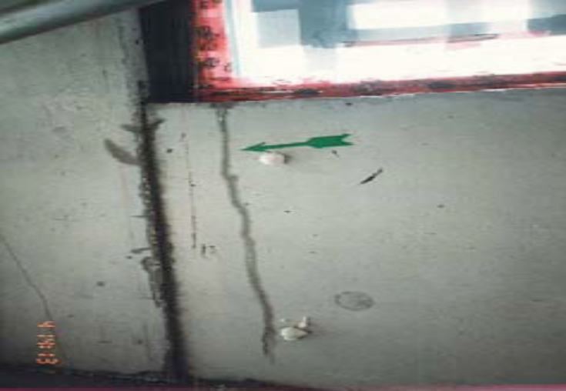
A crack in the foundation, soil too high, a poor drainage at a a window well, poor window installation or poor siding installation can let moisture in and mold can grow.
Basements
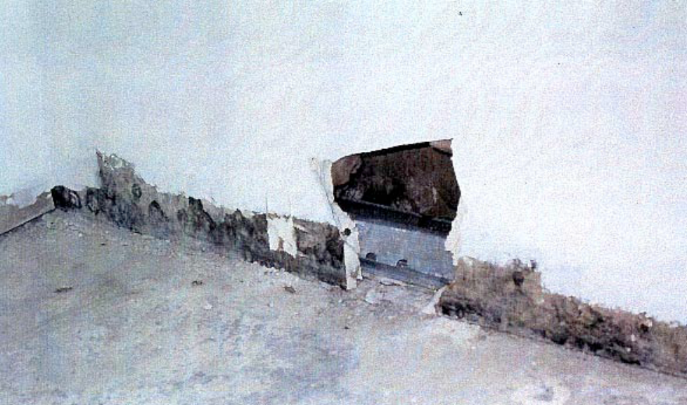
In a basement, drywall can wick water from the concrete, or this could be from careless wet mopping.

Check Your Knowledge
Answer the questions below in the spaces provided

- What is the number one most important thing mold needs in order to grow?
________________________________
- What is a microenvironment? Name 3 examples of microenvironments within which mold may manifest?
_____________________________________________________________________________________________________________________________________________________________________

  - __________________________
  - __________________________
  - __________________________

- What are possible every-day sources of moisture entry into the home?
____________________________________________________________________________________________________________________________________________________________________________________________________________________________

- Briefly describe what impact the RH factors plays in mold growth.
____________________________________________________________________________________________________________________________________________________________________________________________________________________________

Chapter 4
Chapter
4
Controlling Mold Growth

Controlling Mold Growth
Chapter
4
As mentioned previously, the goal is not to remove mold but to inhibit its growth both in the short and long term. Your clients can and should take steps to control the growth of mold in the home. This applies both to sellers as they prepare the home for sale and as excellent advice for buyers to maintain their new home.
Controlling Mold Growth - Basements, Crawlspaces and Attics
- Reduce stored materials
- Dehumidify
- Avoid carpets on slab-on-grade or below grade
- Clean the drains, sumps
- Avoid standing water
- Check for efflorescence, powder, discoloration, odors
- Reduce the amount of clothes, paper and furnishings stored in moisture prone areas. Allow for air circulation, keep them away from walls and off basement floors. Discard water damaged material. Store only washable items
- Dehumidify in warm months since air entering will have a higher moisture content and some could condense in the colder basement or crawlspace. Remove or do not use humidifiers.
- Cover sump pits
- Clean HRV (Heat Recovery Ventilation) system
- Do preventive maintenance checks in hidden areas, crawlspaces, under stairs, storage closets, garages, attics – look at the sheathing, particularly close to the soffits.
- Check the drainage sump outside during a rain storm to see that water is running in and running out. Look for clear water in the sump, clean the sump so that water will not backup in the drainage system around the house and hold water against the foundation.
- Check the attics for any leaks, discoloration, deterioration, high temperature or humidity. Clean soffit vents, do not compromise the roof vents with other equipment – and while you are there, look for any signs of vermin, birds, insects or rodents.
- Do not vent to crawlspaces and do not use them as a source of air for the furnace system. Keep vents open for cross ventilation to promote evaporation.

Controlling Mold Growth – Laundry Areas
- Ensure dryer exhausts to the outside
- Remove lint every time you use the dryer
- Don’t hang clothes to dry indoors
- Dry the laundry tub after using it
- Aerate the room if it is warm
- Often we find dryer ducts disconnected, sometimes inside the wall; or the flapper outside is jammed closed. Ducts going through attics need to be cleaned regularly; a blockage can build up water that can leak and cause considerable damage. Insulate ducts. If the ducts vent through a soffit ensure that the soffits are solid for at least 4’ on each side so moisture does not blow back into the attic.
- Moist air in warm rooms can condense in cold corners leading to mold growth.
- Lint can block the duct or reduce the air flow to the outside leading to a buildup of moisture inside.

Controlling Mold Growth – Bathrooms
- Ensure bathroom fan exhausts to the outside
- Turn fan on when showering, bathing and leave it on for up to ½ hr afterwards. Many new houses have timers on the bathroom fans – to exhaust general moisture in the house, not just the bathroom, so don’t disconnect them. Invest in a quiet fan when needed.
- Wipe moisture from tub & shower walls after using
- Clean then replace caulking
- Clean grout, seal
- Check around toilets for evidence of leaks at base or condensation on tank dripping onto floor
- Remove carpets and replace with ceramic tile or vinyl
- Check for water leaks regularly
- Keep drains free flowing. Remove debris. Use a handful of baking soda and a cup of vinegar; let stand 20 minutes; flush
- We often see dark stains on the caulking – wash it off and if it doesn’t come off, replace the caulking and check the wall.
- Staining on the grout is mildew or mold; clean it, kill it, seal the grout lines every 6 months
- Ensure that the flapper works on the fan exhaust outside, block soffit vents at least 4’ each side of the exhaust so moisture doesn’t enter the attic.
Check behind toilets for mold resulting from condensation on cold tanks – insulate the tanks or replace them. Mold can be toxic here. Check inside the tanks and under the lids too. Check the floor around the toilet – stains indicate long term leakage from a worn toilet seal and probable hidden damage in the floor. Replace the seal and the floor covering, and repair the sub-floor.

Controlling Mold Growth – Kitchens
- Ensure range exhaust hood vents to the outside
- Use the range exhaust hood
- Minimize open boiling
- Clean refrigerator drip pan, vacuum dust from coils
- Check for leaks regularly under sink and around dishwasher
- Take garbage out daily
- Range hood ducts do not always exhaust to the outside. When they go through a cold area such as an attic, they need to be insulated to reduce internal condensation.
- Cooking and particularly cooking with gas is one of the primary sources of water vapor inside the house. Use the range hood.
- We forget about the refrigerator drip pan. One of my inspectors had to pull out his fridge several times a year to clean the mold buildup on the wall behind it. When I renovated my kitchen, I put vents in the side panels to promote air circulation and the kitchen designer is now making it standard in all his designs. So empty the pan if it fills, clean the mold out of it and while you are there, vacuum the dust on the coils to improve the refrigerator’s performance.

Controlling Mold Growth – Bedrooms and Living Rooms
- Open the curtains and blinds
- Clean the windows and frames
- Check for water entry
- Check behind furniture and arrange furniture spaced away from the wall
- Keep stored materials away from the walls
- Reduce the number of plants – soil contains mold
- Don’t bring wet and moldy materials in

Controlling Mold Growth – Exterior
- Check the condition of the roof
- Check building envelope
- Check flashings
- Clean eaves troughs or gutters, extend rain water leaders
- Watch for flat surfaces and reverse slopes
- Monitor soil height
- Check crawlspaces and attics
- Check the roof twice a year – spring and fall.
- Check the siding for any loose pieces, knot holes, cracks, holes, staining. Clean and paint regularly
- Make sure the flashings are not damaged
- Keep the rain from running near the house – directed away.
- Flat surfaces are all the wood trim pieces we see around windows, doors and other decorative trim. Window sills too. Flashings at the base of windows and walls that might not be sloped away, can lead water back into the wall.
- Clean vents of any lint and debris, particularly furnace air vents and crawlspace vents. Ensure crawlspace vents are tight to keep insects and vermin out.
- Don’t let soil within 8” of the top of the foundation and check carefully around sidewalks where siding comes right down to the top of the sidewalk. Best to have a 4 to 6 inch gap there with concrete or masonry instead of siding.
- Correct reverse slopes on sidewalks and patios.
- Water can enter attics and crawlspaces too. Check them regularly.

Check Your Knowledge
Answer the questions below in the spaces provided

  - Name some steps your client can take to control moisture and resulting mold growth in the kitchen?
__________________________________________________________________________________________________________________
  - Name some steps your client can take to control moisture and resulting mold growth the bathroom?
__________________________________________________________________________________________________________________
  - Name some steps your client can take to control moisture and resulting mold growth in the living room and the bedrooms?
__________________________________________________________________________________________________________________
  - Name some steps your client can take to control moisture and resulting mold growth on the exterior?
__________________________________________________________________________________________________________________
  - Name some steps your client can take to control moisture and resulting mold growth in the basement, crawlspace and attic?
__________________________________________________________________________________________________________________
  - Name some steps your client can take to control moisture and resulting mold growth in the laundry area?
__________________________________________________________________________________________________________________
Chapter 5
Chapter
5
Cleaning Up

Cleaning Up
Chapter
5
Because moisture is the key to mold control, it is essential to clean up the mold and get rid of excess water or moisture. If the excess water or moisture problem is not fixed, mold will most probably grow again, even if the area was well cleaned.

Determine the Size
It is important to assess the size (amount) of the mold outbreak in order to determine the next steps. Mold manifestations can be classified into three main categories; small, moderate and excessive.
Small: No larger than one sq m
Clean up using: rubber gloves, dust mask and goggles to protect eyes. In terms of protective clothing - long sleeves, long pants and socks.

- Wash with unscented detergent, sponge dry. Use baking soda or detergent on drywall. Leave open to air dry, use a fan if you have one.
- Absorbent materials such as ceiling tiles may have to be discarded.
- If mold is under paint, then remove the drywall and any other damaged material and replace it.
- Vacuum wood with a HEPA vacuum use detergent, sponge dry, open windows.
- Concrete can be vacuumed cleaned with detergent or TS
- Replace caulking, clean and seal grout
Your client may be tempted to paint over the patch. You must caution them however not to do so. Painting only masks the problem; it does not kill mold nor stop it from growing.

Moderate: More than 3 patches each smaller than a sq m or one or more patch larger than 1 sq m but smaller than 3 sq m – 4x8 plywood
This should be sampled and evaluated by a professional to determine next steps. Many home inspectors are qualified to perform sampling and evaluation protocols. Although this is not a part of the core home inspection, the home inspector may offer this as an additional service and will typically charge an additional fee.
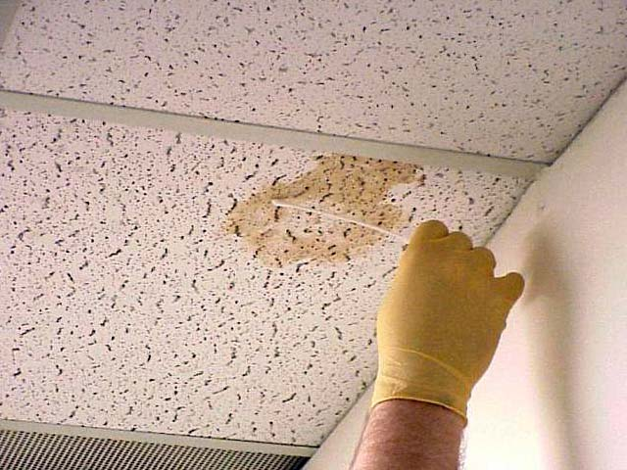
A professional sampling can be done by using a swab, cutting out a piece, or taking air samples.

Extensive: More than 3 sq m call a professional.
This should be sampled, evaluated and remediated by professionals. Again, many home inspectors are qualified to perform sampling and evaluation protocols however most will not perform the remediation (clean-up) itself.

Check Your Knowledge
Answer the questions below in the spaces provided

- What are the three sizes of mold outbreaks?
- ____________________________________
- ____________________________________
- _____________________________________

- What would be considered a small mold incident?
______________________________________________________________________________________________________________________________
- To clean up small mold incidents what protective gear and clothing should your client use?
__________________________________________________________________________________________________________________________________________________________________________________________________________________________________________________________________________________________________________________________________________________________________________________________
- Should the client paint over the mold patch instead of cleaning it? Why, Why not?
____________________________________________________________________________________________________________________________________________________________________________________________________________________________________________________________
Chapter 6
Chapter
6
CEP Quiz

Mold Quiz

Name: ________________________

- What is the primary natural function of mold?
_________________________________________________________

- Which of these is not a characteristic of mold: toxigenic, photogenic, allergenic, pathogenic?
_________________________________________________________

- True of False. Painting gets rid of mold.

- True or False. Opening a bathroom window will contribute to mold growth.

- Name three elements that molds need to propagate.
__________________________________________________________

- Why do insurance companies and mortgage companies go to great lengths to deal with mold?
__________________________________________________________

Chapter 7
Chapter
7
Presentation Evaluation

Presentation Evaluation – Mold

TECHNICAL CONTENT Excellent Average Poor No Opinion
Presenter's knowledge of subject matter ○ ○ ○ ○
Ability to keep you interested ○ ○ ○ ○
Discussion / overview / recap ○ ○ ○ ○
How well did this course meet your expectations? ○ ○ ○ ○
Comments: ________________________________________________________________________________________________________________________________________________________
ORAL PRESENTATION Excellent Average Poor No Opinion
Explanation of objectives ○ ○ ○ ○
Voice (volume, clarity, speed) ○ ○ ○ ○
Answers question clearly ○ ○ ○ ○
Comments: ________________________________________________________________________________________________________________________________________________________
VISUAL PRESENTATION Excellent Average Poor No Opinion
Voice (volume, clarity, speed) ○ ○ ○ ○
Answers question clearly ○ ○ ○ ○
Effectiveness of visual aids ○ ○ ○ ○
Presenter's eye contact ○ ○ ○ ○
Comments: ________________________________________________________________________________________________________________________________________________________
MATERIAL HANDOUTS Excellent Average Poor No Opinion
Effectiveness of handouts ○ ○ ○ ○
Comments: ________________________________________________________________________________________________________________________________________________________
Please complete this portion:
Location: ___________________________________ Date: ________________________
Name (optional): _______________________________ License# (optional): ______________

Pillar To Post
© Pillar To Post

14502 N. Dale Mabry Hwy., Suite 200,
Tampa, FL 33618

5805 Whittle Road, Suite 211
Mississauga, Ontario
L4Z 2J1

01/20/2008

